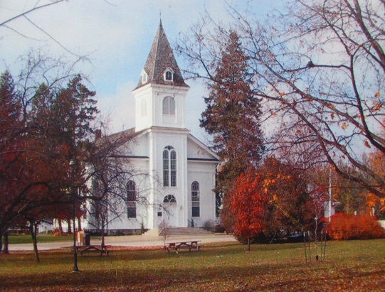

NON-MEMBER
WEDDING SERVICE CHARGES

Non-members wishing to use the sanctuary of First Presbyterian Church in Richland for a wedding ceremony will be charged $900.00. This amount includes use of the church, custodial fees, a wedding coordinator, the organist, and the pastor.

After a call to the office to confirm a date and to reserve the church sanctuary, a deposit of $200 and the Wedding Information sheet needs to be returned as soon as possible. It should be noted that the date and time cannot be finalized until twelve months prior to the actual wedding date. The remaining fees need to be paid no later than two weeks prior to the wedding itself. All fees will be refunded if the wedding ceremony is canceled.

Checks should be made payable to First Presbyterian Church.

Send to: First Presbyterian Church
Attn: Wedding
8047 Church Street
Richland, MI 49083

